SUPPORT VECTOR MACHINE ASSIGNMENT:

1. Prepare a classification model using SVM for salary data

CODE:

# -*- coding: utf-8 -*-

"""

Created on Tue Nov 17 13:39:47 2020

@author: sunil

"""

import pandas as pd

import numpy as np

import seaborn as sns

from sklearn import preprocessing

salary = pd.read_csv("SalaryData_Test.csv")

salary.drop(["capitalloss","capitalgain"],axis=1,inplace=True)

salary.columns

string_columns=['workclass','education','maritalstatus','occupation','relationship','race','sex','native','Salary']

number = preprocessing.LabelEncoder()

for i in string_columns:

salary[i] = number.fit_transform(salary[i])

salary.head()

salary.describe()

salary.columns

sns.boxplot(x="age",y="Salary",data=salary,palette = "hls")

sns.boxplot(x="native",y="age",data=salary,palette = "hls")

from sklearn.svm import SVC

from sklearn.model_selection import train_test_split

train,test = train_test_split(salary,test_size = 0.3,random_state=0)

test.head()

train_X = train.iloc[:,:11]

train_y = train.iloc[:,11]

test_X = test.iloc[:,:11]

test_y = test.iloc[:,11]

model_linear = SVC(kernel = "linear")

model_linear.fit(train_X,train_y)

pred_test_linear = model_linear.predict(test_X)

np.mean(pred_test_linear==test_y) # Accuracy = 80.23

# Kernel = poly

model_poly = SVC(kernel = "poly")

model_poly.fit(train_X,train_y)

pred_test_poly = model_poly.predict(test_X)

np.mean(pred_test_poly==test_y) # Accuracy = 79.9

# kernel = rbf

model_rbf = SVC(kernel = "rbf")

model_rbf.fit(train_X,train_y)

pred_test_rbf = model_rbf.predict(test_X)

np.mean(pred_test_rbf==test_y) # Accuracy = 79.8

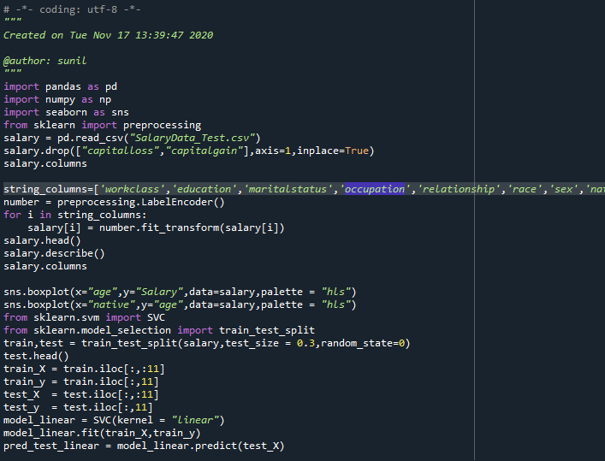

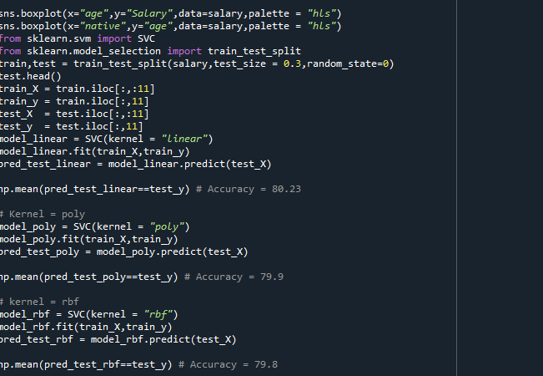

**Output:**

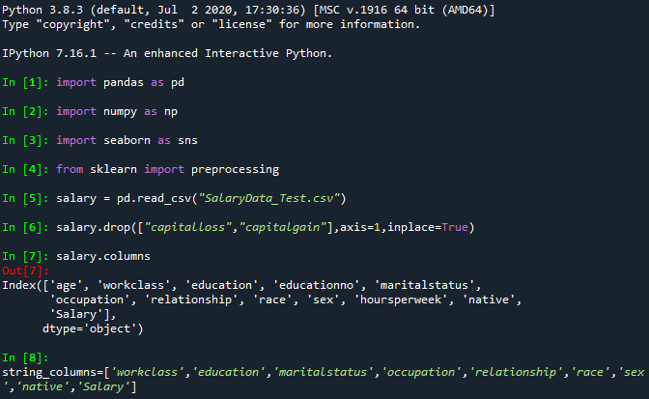

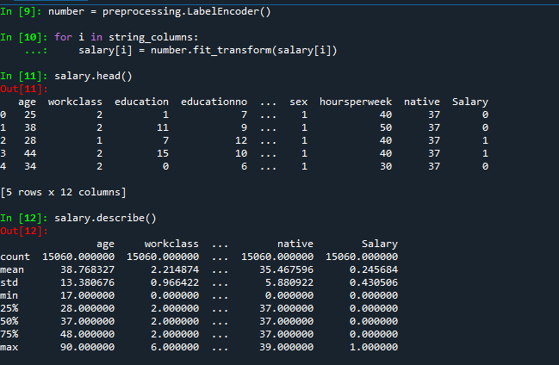

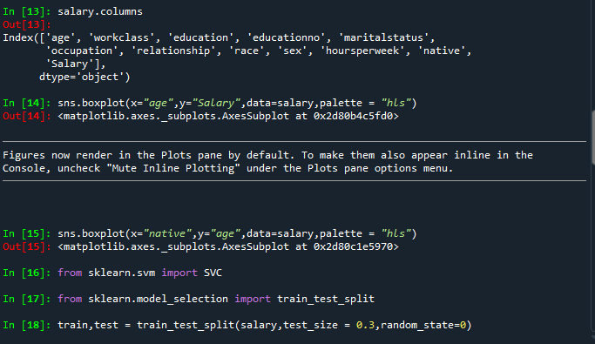

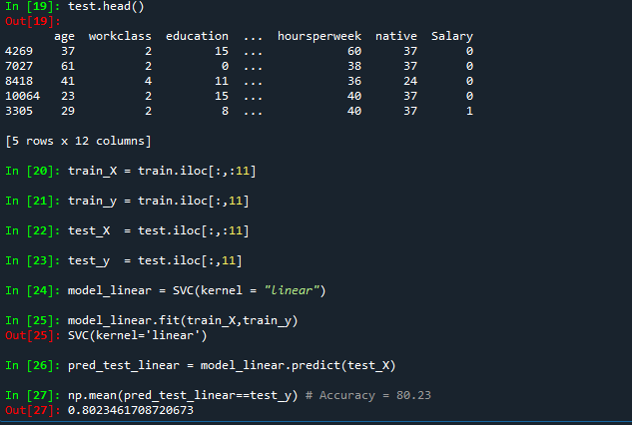

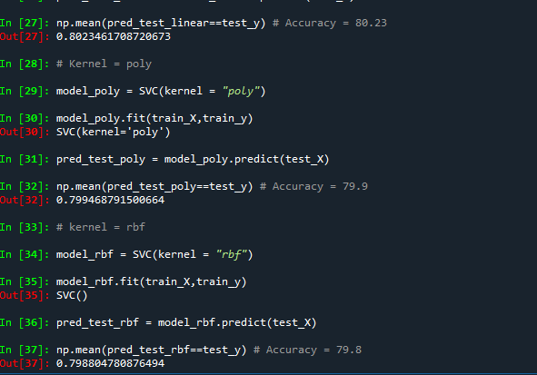

**PLOTS:**

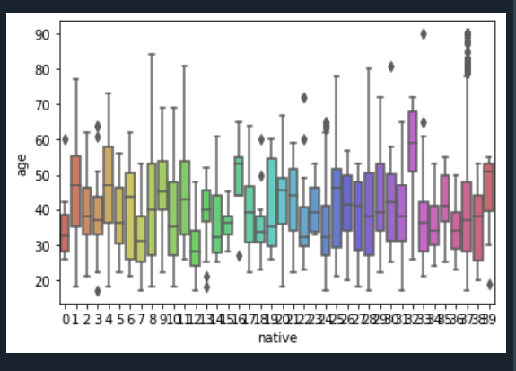

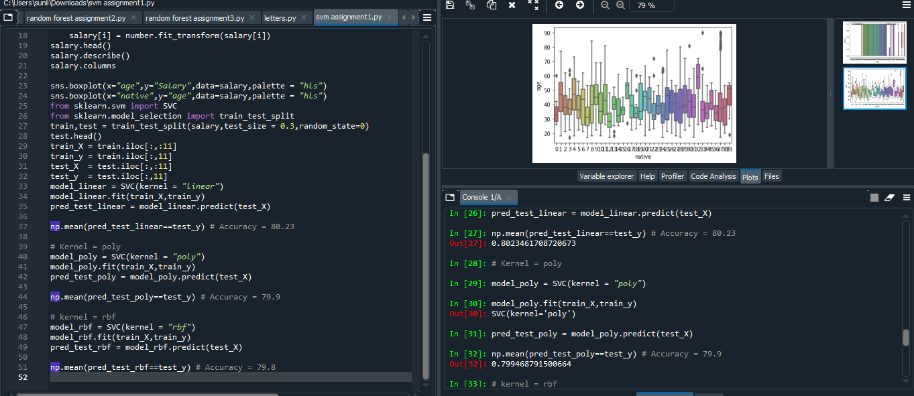

**2)WITH “FORESTFRIES.CSV” DATASETS:**

**CODE:**

# -*- coding: utf-8 -*-

"""

Created on Tue Nov 17 12:27:37 2020

@author: sunil

"""

import pandas as pd

import numpy as np

import seaborn as sns

from sklearn import preprocessing

data = pd.read_csv("forestfires.csv")

string_columns=['day','size_category']

number = preprocessing.LabelEncoder()

for i in string_columns:

data[i] = number.fit_transform(data[i])

data.head()

data.describe()

data.columns

sns.boxplot(x="month",y="FFMC",data=data,palette = "hls")

sns.boxplot(x="FFMC",y="month",data=data,palette = "hls")

#sns.pairplot(data=letters)

from sklearn.svm import SVC

from sklearn.model_selection import train_test_split

train,test = train_test_split(data,test_size = 0.3,random_state=0)

test.head()

train_X = train.iloc[:,1:]

train_y = train.iloc[:,0]

test_X = test.iloc[:,1:]

test_y = test.iloc[:,0]

model_linear = SVC(kernel = "linear")

model_linear.fit(train_X,train_y)

pred_test_linear = model_linear.predict(test_X)

np.mean(pred_test_linear==test_y) # Accuracy = 94.23

# Kernel = poly

model_poly = SVC(kernel = "poly")

model_poly.fit(train_X,train_y)

pred_test_poly = model_poly.predict(test_X)

np.mean(pred_test_poly==test_y) # Accuracy = 75.0

# kernel = rbf

model_rbf = SVC(kernel = "rbf")

model_rbf.fit(train_X,train_y)

pred_test_rbf = model_rbf.predict(test_X)

np.mean(pred_test_rbf==test_y) # Accuracy = 76.9

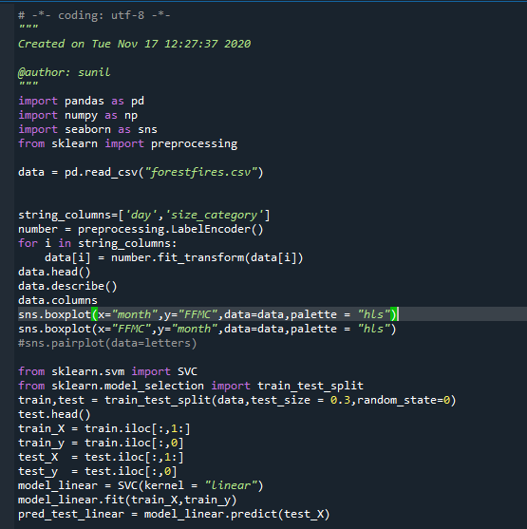

OUTPUT:

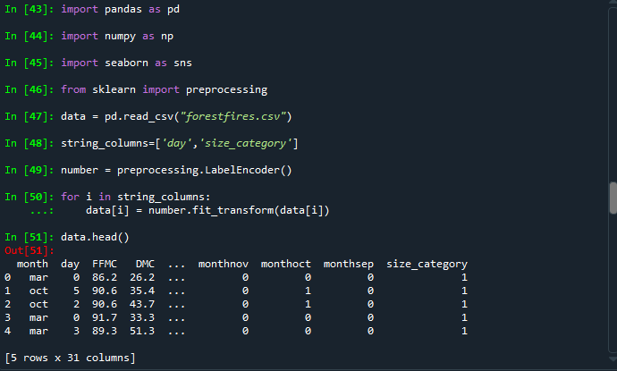

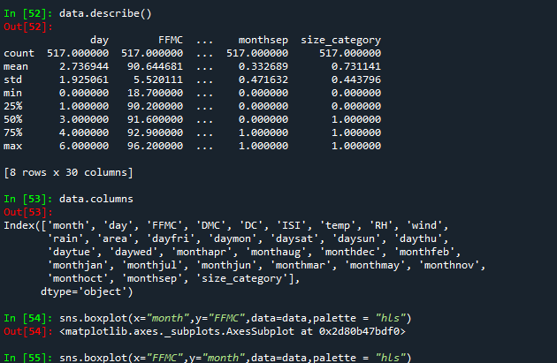

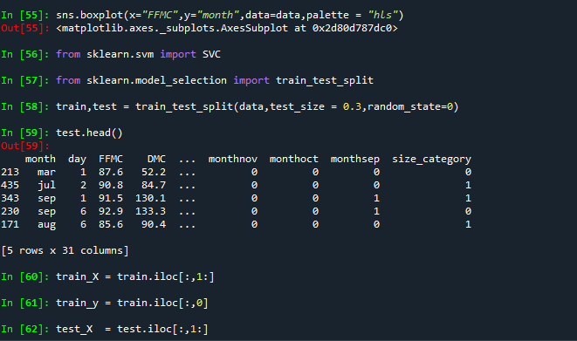

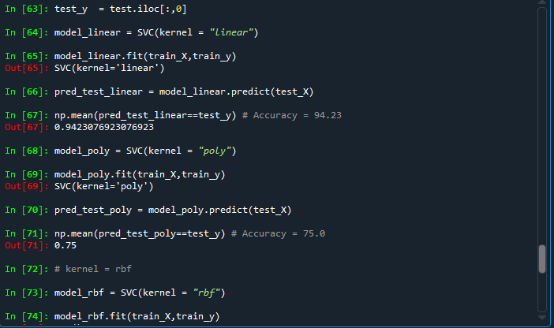

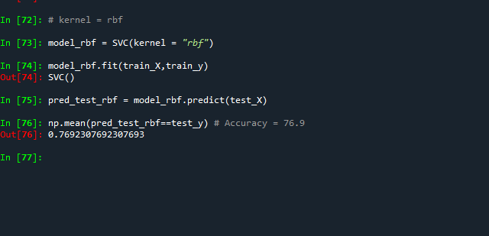

PLOTS:

